**INVESTIGATION REPORT**

**DOCUMENT REFERENCE NO.: SYN/GMP/DEV/2020-XXXX (PR#22088)**

**DATE OF INITIATION: 28 JULY 2020**

# **SOURCE OF NON-CONFORMITY / UNEXPECTED OUTCOME**

|  |  |  |
| --- | --- | --- |
| **Source of Non-Conformity** | **Category of Non-Conformity**  **(Critical / Major / Minor)** | **Document Reference Number** |
| ✓ Deviation | Major | SYN/GMP/DEV/2020-XXX |
| OOS | NA | NA |
| OOT | NA | NA |
| Customer Complaint | NA | NA |
| Any other _____________________ | NA | NA |

# **(**✓ tick which ever is applicable)

# **DESCRIPTION OF THE NON-CONFORMITY/** **UNEXPECTED OUTCOME:**

* 1. **Description:**

On 17 July 2020, Miss.Darshini priya (Emp. ID.: 10007979) of QCM microbiology recorded the environmental monitoring results of the BMP-3 area monitoring in the relevant observation data sheets at S19 EM lab. The said environmental monitoring was carried out on 10 July 2020 BMP-3 facility.

During the entry of the results the target monitoring results were recorded in the FORM-GMP-QCM-0073 of regular monitoring observation data sheet for the Locations SP-79 and SP-80 of B3G112 BMP-3 facility. (Refer attachment -1)

* 1. **Reference Documents/Instruments/Equipment/Products/Others:**

1. The Monitoring activity was performed as per the SOP No: SOP-GMP-QCM-0010, Title: Environmental monitoring of clean room areas in BMP-3 facility.
2. FORM-GMP-QCM-0073 was executed for the environmental monitoring of clean rooms in BMP-3 (Grade A and B) for Passive air sampling, Active air sampling and surface monitoring on 10 July 2020.The personnel involved in the monitoring and time of monitoring is detailed in table-1.
3. Similarly FORM-GMP-QCM-0088 (Target monitoring) was executed for aseptic activity in Biosafety cabinet (S18 BM3-LAF-02) for Passive air sampling and personnel monitoring on 10 July 2020. (Refer Table-1 for date and time and employee details)
4. FORM-GMP-QCM-0073 will be used for the regular area monitoring, FORM-GMP-QCM-0088 will be used for the target monitoring.
   1. **Sequence of events:**
5. The Environmental monitoring was carried out as mentioned below

**Table-01**

|  |  |  |
| --- | --- | --- |
| **Date** | **Time (Hours)** | **Event** |
| 10 July 2020 | 1141 to1615 | Monitoring performed by the analyst Mr.Prabhakaran |
| 10 July 2020 | 1615 to 2023 | Monitoring performed by the analyst Mr.Prabhakaran |
| 10 July 2020 | 2030 to 2216 | Monitoring performed by the analyst Mr. Deepak |
| 10 July 2020 | 2301 | Monitored plates were incubated at 20-25°C-S19/QCM/LE/001 along with the negative control plates by the analyst Mr.Deepak |
| 14 July 2020 | 0844 | Monitored plates were transferred along with the negative control plates to 30-35°C- S19/QCM/LE/002 by the analyst Miss.Darshinipriya.(100 |
| 17 July 2020 | 1120 | BMP-3 incubated plates were released by the analyst Miss Darshini priya. |
| 17 July 2020 | 1041 to 1205 | Miss Darshini Priya (10024182) released the plates (refer Table-06) an the results were recorded in the presence of IPQA personnel Mr.Jebba singh (10019805) (Verified by) and reviewed by QCM personnel Mr.Aleemuddin.  Microbial excursions were observed and initiated OOS (Refer PR 21654) |
| 18 July 2020 | 1046 | OOS-PR 21654 initiated for the observed Microbial excursions. |

**Inference:**

The continuous target monitoring was started at 1141 to 2216.During the exposure of SET-III plates at 2030 there was a delay of 07 minutes after the removal of set-II monitoring plates at 2023.The analyst (Mr. Deepak-10025074) has delayed in getting issuance of plates by the IPQA personnel (Mr.Elayaraja-10025100) and plates were sealed by the IPQA personnel (Mr.Santosh-10020272)

Analyst Miss. Darshini Priya involved in the release of monitoring plates from 1041 to 1205 as per the colony counter usage record-S19/QCM/LE/033.It was observe the analyst involved in the release of plates from 1041 1205 for the release of plates related to AR.No.S18/BMP-1/EM/20-0530, S18/BMP-1/EM/20-0531 and **S18/BMP-3/EM/20-0534.**

However the incubation for the AR.No. S18/BMP-1/EM/20-0530, S18/BMP-1/EM/20-0531 and S18/BMP-1/EM/20-0534 was completed at 1039,1100 and 1120 hours.

The Environmental monitoring results were obtained on 17 July 2020 and the OOS was logged on 18 July 2020 by the analyst Madhuvenkata Shami reddy (10021693). The OOS was logged within 24 hours of the observation.

* 1. **Initiator Name and Department:**

|  |  |  |  |
| --- | --- | --- | --- |
| **DEV NO** | **INITIATED BY** | **DATE OF INITIATION** | **DEPARTMENT** |
| SYN/GMP/DEV/2020-0615 | Mohamed Aleemuddin Z | 27 Jul 2020 | QC-Microbiology |

# **INVESTIGATION TEAM:**

**Table-02**

|  |  |  |
| --- | --- | --- |
| **Name** | **Designation** | **Department** |
| Mr. Mohamed Aleemuddin Z | Junior Manager | QC-Microbiology |
| Mr. Eshwara | Manager | QC-Microbiology |
| Mr. Shashi Kumar | Junior Manager | Quality Assurance |
| Mr. Madhusudana | Assistant Manager | Quality Assurance |

# **INVESTIGATION AND ROOT CAUSE ANALYSIS:**

* 1. **Initial/Preliminary Impact assessment:**
* The environmental monitoring was carried out as per the SOP: SOP-GMP-QCM-0010 (Environmental monitoring of clean room in Biologics manufacturing plant-3)
* Product :1591 LBP DP OD 5 (30ml Bottle) of batch number GF20000027 filling activity was executed on 10 July 2020.
* The Microbial analytical results (BET and Bioburden) with respect to batch number GF20000027 results found complies.
* Based on the Microbiological analytics test results the delay in exposure of SET-III monitoring plates for 07 minutes does not have any potential impact on the batch.
* However, from the said deviation there is no direct impact on the quality of the batch manufactured and the excursions observed during the batch filling activity is separately dealt with PR 21654 OOS investigation (Laboratory and Manufacturing investigation).
  1. **Escalation criteria:**
* The Deviation was initiated (27 July 2020) during the OOS (PR 21654) review by QA.
* The Deviation was notified to the cross functional team (Production and User department head) through track wise deviation on 31 July 2020.
* The nonconformance is classified as Major as per the deviation SOP (SOP-GMP-QA-0007)
* No such nonconformance were notified by any of the analyst during the observation/recording the results.
* As an immediate action the reconciliation of the media plates of the lot SCDA(L+P) 90 mm lot No:MPD0312 Exp: Oct 2020,and SCDA 55 mm (L+P) SPY088,Exp:Dec 2020 were verified and found satisfactory (Log book Numbers : 90mm:S19/QCM/2020/00004 page no :28 and 29,55 mm S19/QCM/2020/00029 page No:50 and S19/QCM/2020/00005,page no:01,refer attached media reconciliation sheet:Attachemnt)
* **Correction:** Based on the availability of the excursions plates which are stored for the identification purpose the counts of the respective sets has been evaluated with the (Photographical evidence and the same is included in the investigation.
* The deviation log was verified in the track wise for past one year i.e, and found no such incident was reported.
* Analysts involved in Environmental Monitoring of BMP3 area and analyst involved in the release of media plates and IPQA were interviewed and following are the outcomes:
* **Details of Personnel interacted:**

|  |  |  |
| --- | --- | --- |
| **Name and Employee code of Analyst** | **Activity Performed** | **Training Status**  **(Available/Not Available)** |
| Mr. Prabakaran (10023035) | Monitoring of area | Available |
| Mr. Deepak (10025074) | Monitoring of area and incubation of media plates | Available |
| Ms. Darshini priya (10024182) | Transfer of media plates to 30ºC-35ºC and plates release | Available |
| Jebba Singh | Plate release activity | Available |
| Elaya raja | Supervision of EM activity | Available |
| Santosh | Supervision of EM activity | Available |
| Mohd Aleem | Plate release activity | Available |
| Prem tej | Supervision of EM activity | Available |

* Darshini Priya : The training records of Based on the investigation the probable root cause for the deviation.
* SOP: SOP-GMP-QCM-0010 (Environmental monitoring of clean room in Biologics manufacturing plant-3)
* The entry and exit in S19 Microbiology laboratory SOP-GMP-QCM-0022 was reviewed and found satisfactory with respect to defined procedure.
* Incubator
* Colony counter
* Deepak and Prabhakran training records were verified and the training records were available in place (Respective training files).
* As per the SOP SOP-GMP-QCM-0010 “Environmental Monitoring of the Clean Rooms in Biologics Manufacturing Plant 3”. passive air sampling, surface monitoring and active air sampling were performed by the qualified analyst. Refer attachment No XX.
* The entry and exit in S19 Microbiology laboratory SOP-GMP-QCM-0022 was reviewed and found satisfactory with respect to defined procedure.
* The entry and exit of BMP3 facility SOP-GMP-BMP3-OPS-0002 was reviewed and found satisfactory.
* Media preparation SOP “Handling of Microbiological Media” S/QCM/SOP/008 and “Test for growth promotion, indicative and inhibitory properties of media” GP-GMP-QCM-0003 were reviewed and found satisfactory with respect to the defined procedures
* Jebba singh and Mohammed Aleemuddin training records for the plate release activity was verified and the training records were available in place. (SOP: SOP-GMP-QCM-0010 (Environmental monitoring of clean room in Biologics manufacturing plant-3) and The entry and exit in S19 Microbiology laboratory SOP-GMP-QCM-0022 was reviewed and found satisfactory with respect to defined procedure.
* Elaya raja,Santosh , and Premtej training record for the supervision of the monitoring activity was verified and the training records were available in place (SOP: SOP-GMP-QCM-0010 (Environmental monitoring of clean room in Biologics manufacturing plant-3).
* Media reconciliation sheets were verified and no deviation observed .
* The Incubator used for incubation of the plates was well maintained in the acceptance range of temperatures and found no equipment break down.
* Personnel involved in area monitoring were qualified analysts.(Refer Attachment)
* Analyst Prabhakaran (10023035) and Deepak (10025074)were involved in the monitoring performed on 10 July 2020.
* The Monitoring activity was carried out in the presence of IPQA personnel.
* Before initiation of Environmental Monitoring activity, IPQA visualize the plates for rejections such as cracks air bubbles, condensation, dryness of media, particles or unequal layer of media.
* Personnel involved from IPQA were Mr.Elaya raja and Mr.Prem tej(10018259)
* 10 plates of 90 mm and 35 plates of 55mm were rejected (rejection is done during the visualization of plates by the IPQA personnel) and the no.of plates rejected detailswere recorded in respective ODS.(FORM-GMP-QCM-0073)
* One media plate as such (without exposure) is used as the negative control plate for the activity.
* After the issuance of plates by the IPQA personnel the plates were used for sampling purpose.
* The labelling of the plates were done by QC Microbiologist with Area name, sampling point number, date of sampling and signature of the analyst before the exposure of the plate.
* The Environmental monitoring plates were transferred from S19 QC-Microbiology to BMP-3area and BMP-3 area to S19 QC microbiology as per the SOP-
* The Regular monitoring was executed by Mr.Prabhakaran and the details are as follows:

Table :03

|  |  |  |
| --- | --- | --- |
| **Passive Air sampling** | **Active air sampling** | **Surface Monitoring** |
| LAF:02- 1141 to1615 | LAF:02- Refer Print out | LAF:02- 1150 to1151 |
| BSC:02-1221 to 1634 | BSC:01- Refer Print out | BSC:02-1228 to 1229 |
| BSC:01-1225 to 1632 | BSC:01- Refer Print out | BSC:01-1231 to 1232 |
| LAF:01- 1301 to1704 | LAF:02- Refer Print out | LAF:01- 1304 to1305 |

* The target monitoring is performed by Passive Air sampling inside the BSC/LAF and surrounding area, during the Final filling and pooling activity.
* Since both the target monitoring and routing monitoring frequencies are scheduled for Grade A and B areas, only target monitoring will be done for the day and considered as routine monitoring.
* The details of the target monitoring carried on XXXX is as follows.
* Table -04

|  |  |  |  |
| --- | --- | --- | --- |
| **Location ID** | **SET-I** | **SET-II** | **SET-III** |
| SP-79 | 1141 to 1615 | 1615 to 2023 | 2030 t0 2216 |
| SP-80 |
| Performed By | Prabhakaran | Prabhakaran | Deepak |

* Finger dab (Gloves sampling) in grade A of the personnel working in the BSC/LAF was collected after the completion of activity in the BSC/LAF area.
* After sampling, the plates wereare wrapped with clean room tapes sealed by microbiology personnel and acknowledged by IPQA personnel with signature and date , and the plates are placed in SS bins and transferred to Microbiology laboratory for incubation by Deepak on 10 July 2020 at 2301 hrs.
* The sealing of plates with the clean room tapes ensure the intact ness of the plates during the transfer of plates from the BMP-3 facility to S19 QC Microbiology Laboratory
* The SS bins with monitored plates were transferred from production area to S19 QC microbiology laboratory
* The media plates were incubated at 20-25 °C for 72 hours followed by 30-35°C for 48 hours in inverted position.
* Analyst (Darshini Priya) has transferred the incubated plates from 20-25 °C to 30-35°C incubator on 14 July 2020 at 0844 hrs and after 48 hours of incubations plates were released on 17 July 2020 at 1120 hrs.
* After completion of incubation, the results were recorded in respective FORM in “recorded by” column by the QCM personnel (Darshini) and the results were verified by QA personnel (Jebba singh).

|  |  |
| --- | --- |
| **Equipment Number** | **Equipment Name** |
| S19/QCM/LE/033 | Colony counter |
| S19/QCM/LE/034 | Colony counter |

* On 17 July analyst Darshini released the following area plates.

|  |  |  |
| --- | --- | --- |
| **S.No** | **Activity performed** | **Time (Hours)** |
| **Colony counter ID: S19/QCM/LE/033** | | |
| 1 | S18/BMP1/EM/20-0530 (1039) | 1041 to 1205 |
| 2 | S18/BMP1/EM/20-0531 |
| 3 | S18/BMP3/EM/20-0534 |
| **Colony counter ID: S19/QCM/LE/034** | | |
| 4 | S18/BMP3/EM/20-0536 | 1213 to 1221 |
| 5 | S18/QCM1/EM/20-0052 | 1501 to 1510 |
| 6 | S18/BPD/EM/20-0537 | 1614 to 1621 |
| 7 | S18/QCM1/EM/20-0538 |

* During the reporting of the results it was identified the analyst who involved in the monitoring has not marked the plates as SET-I,SET-II and SET-III.
* The details of the results entered by Darshini Priya were as follows for the target monitoring locations are as follows.

|  |  |  |  |  |
| --- | --- | --- | --- | --- |
| **Sampling ID** | **Regular Monitoring** | **Set-I** | **Set-II** | **Set-III** |
| SP-79 | 00 | 08 | 02 | 00 |
| SP-80 | 02 | 01 | 01 | 00 |

* as part of the investigation (interviewed the anlysts-Mr,Prabhakaran and Mr.Deepak) it was revealed that there was no regular monitoring carried out for the sampling locations SP-79 and SP-80 as there was target monitoring.
* During the execution of the activity the analyst (Prabhakaran) has missed to strike the sampling location (79 and 80) as NA.
* The values were reported as per the sampling locations.
* To conclude the error the OOS was initiated for the excursion observed in the target monitoring plates. During the investigation of the OOS it was identified there were redundant entries in reporting the results.
* Then the Excursion plates which were stored for the identification purpose were verified based on the signatories and sampling details it was identified the reported results with respect to sampling location SP 79 and SP80 were not matching.
* Based on the plate’s availability and the reporting of the values will be recorded accordingly in the presence of QA and photograph evidence of the countsplates will be read as mentioned below.attached

|  |  |  |  |  |
| --- | --- | --- | --- | --- |
| **Sampling ID** | **Regular Monitoring** | **Set-I** | **Set-II** | **Set-III** |
| SP-79 | NA | 01 | 00 | 08 |
| SP-80 | NA | 02 | 01 | 00 |

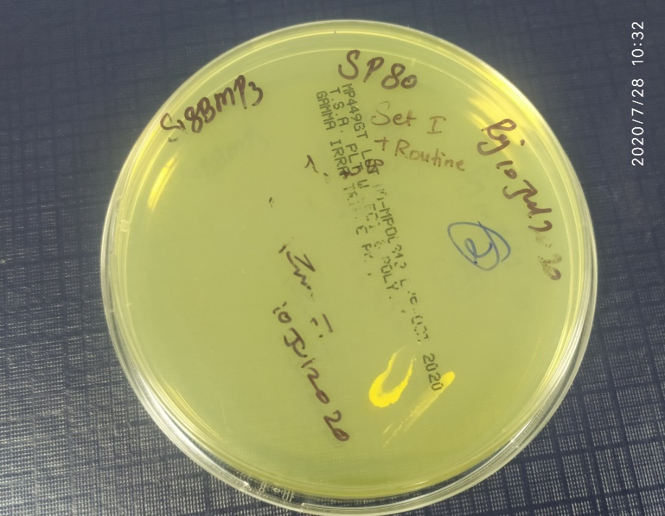

SET-I Plate

Exposed By: Prabhakar Rajendran

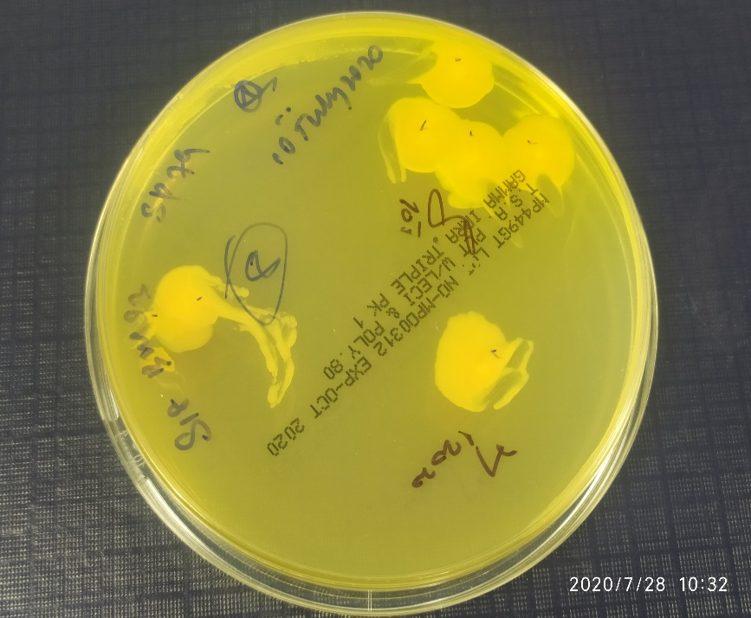

SET-III Plate

Exposed By: Deepak

Identified as SET-III plate based on the signature of analyst on the plate.

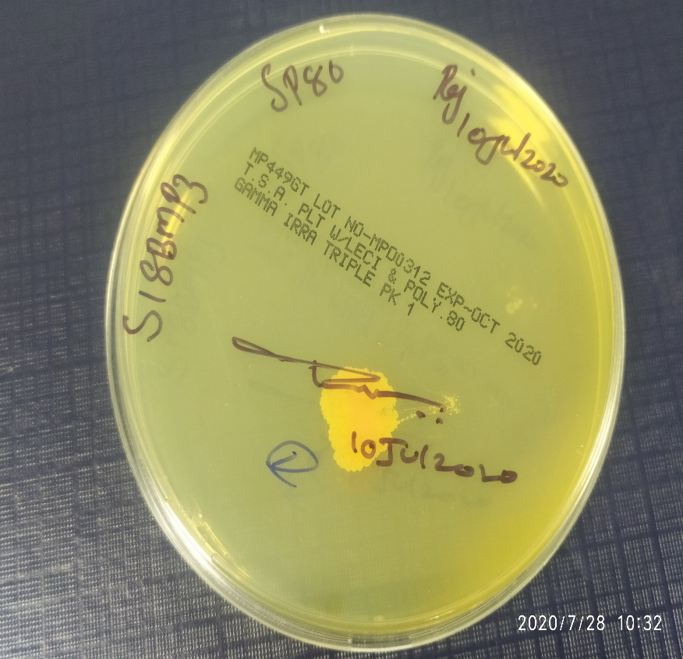

SET-II Plates

Exposed By: Prabhakar Rajendran

SP-80 Set-I plate is available with Label and the SET-III plate is exposed by Deepak,therefore the available plate relates to SET-II

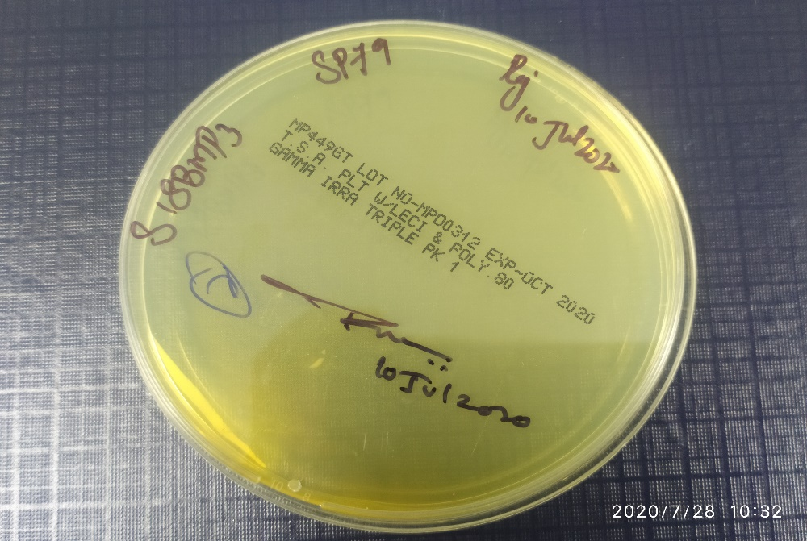

SET-I/SET-II Plates

Exposed By: Prabhakar Rajendran.

This plate may associated to SET-I/SETII

**Note:** There is an ambiguity in the results of SP-79 does it belongs to either Set-I /Set-II.However it is evident that the microbial recovery were observed during the filling activity.

* **Personnel Interview:** Personnel involved in Environmental Monitoring of BMP3 area were interviewed and following are the outcomes:

**Question 01:** Why the target monitoring results were entered in the regular monitoring data sheet? (Darshini Priya ,Jebba singh and Aleemudin))

**Answer 01** : The team involved in the plate release revealed that the labelling on the media plate was not done as SET-I ,SET-II and SET-III specifically,instead the labelling was done as SP-79 and SP-80 for all the sets.

Answer-02: The regular monitoring data sheet for the sampling location SP-79 and SP-80 was not marked as NA by the analyst (Prabhakaran).

Answer-03: The same regular monitoring data sheet was strike off by the analyst Deepak, however on the same day it was acknowledged by Deepak as wrongly stricken.

**Question 02**: Why the labelling was not done on the media plates with respect to SET-I, SET-II and SET-III and data sheet strike off by the analyst?

**Answer** : The Analyst revealed that since they are new to the BMP-3 facility area monitoring ,unable to remember the full information about the procedure and activity.

**Question 03:** How the counts were taken when labelling was not available on the plates as SET-I ,SET-II and SET-III ?

**Answer** : The results were entered in the ODS as per the sampling locations labelled on the media plates.

**Question 04:** Why the plates were not verified against the observation data sheet according to sampling locations?

**Answer** : The SOP does not states that plates verification while executing the counting activity.

**Question 05:** Were there was any excursions observed during the release of the plates?

**Answer :** Yes,the microbial excursions observed in AS 68 ,AS 70 and personnel monitoring of Mr.Balaji (Right hand finger dab) along with the SP-79 and SP-80 locations.(Pictorial representation of plates included in the investigation)

**Inference:** Analyst who involved in the monitoring (Prabhakaran) has not striked off the location of SP-79 and SP-80 as NA in regular monitoring Later the second analyst Deepak has striked off the page number 03 of 08 and acknowledged the mistake with a comment as wrongly striked off.

The results were reported in the observation data sheet by Darshini Priya with respect to the sampling locations. The analysts involved in the monitoring activity is missed to execute the assigned responsibilities attentively.

# **IMPACT ASSESSMENT:**

# Impact on the quality of the product:

* The plate count activity is being carried out by the analyst from the month of June 2020.
* The Observed count with the microbial excursions were reported for four plates with respect to locations SP-79 and SP-80.
* The four plates (Related to SP-79 and SP-80) are stored for microbial identification and the photographs are included in the investigation as an evidence.
* The excursions from the specification are addressed through OOS investigations. The impact on the facility are evaluated in the OOS investigations.

# **CORRECTIVE AND PREVENTIVE ACTIONS:**

* AS a part of corrective and preventive action training is given to relevant personnel on GDP practice.
* Training and instructions given to the personnel involved in Environmental monitoring plates regarding the labelling of the plates that it should be written on the bottom side of the media plate not on the clean room tape.
* Instructions given to IPQA personnel to sign on the clean room tape only if labelling of the plate with sampling location and SET is written on the bottom side of the media plate.
* SOP will be revised to include the plates released will be cross labelled with marker and excursion plates will be signed by the QA personnel for investigation purpose.

# **SUMMARY & CONCLUSION:**

Based on the investigation it is evident that the event has occurred due diligence of the analyst during the execution of the relevant activities (Environmental monitoring and Colony counting i.e plate release activity).To restrict the recurrence of the above said incident training was imparted to the relevant personnel (QCM and IPQA personnel) on GDP practices,Labelling of the media plates and final acknowledgement of IPQA personnel on clean room tape.

# **ATTACHMENTS**

* Media Reconciliation sheet.
* Environmental monitoring ODS.

# **ABBREVIATIONS:**

# **INVESTIGATION TAM:**

# *Not applicable since track wise investigation performed with electronic signature

|  |  |  |  |  |
| --- | --- | --- | --- | --- |
|  | **Name** | **Designation** | **Department** | **Sign & Date** |
| **Prepared by**  **(User Department)** |  |  |  |  |
| **Reviewed by**  **(HOD/Designee)** |  |  |  |  |
| **Reviewed by (Investigation Team)** |  |  |  |  |
| **Approved by (QA)** |  |  |  |  |